HW 21.2

> dat = matrix(c(31,57,87,52,10,7,33,60,44,19), ncol = 5, byrow= TRUE)
> chisq.test(dat)

Pearson's Chi-squared test

data: dat
X-squared = 16.864, df = 4, p-value = 0.002054

> library(gmodels)
> CrossTable(dat)
Total Observations in Table: 400

|
| [,1] | [,2] | [,3] | [,4] | [,5] | Row Total |
-------------|-----------|-----------|-----------|-----------|-----------|-----------|
[1,] | 31 | 57 | 87 | 52 | 10 | 237 |
| 3.198 | 0.253 | 0.000 | 0.419 | 3.002 | |
| 0.131 | 0.241 | 0.367 | 0.219 | 0.042 | 0.593 |
| 0.816 | 0.633 | 0.592 | 0.542 | 0.345 | |
| 0.077 | 0.142 | 0.217 | 0.130 | 0.025 | |
-------------|-----------|-----------|-----------|-----------|-----------|-----------|
[2,] | 7 | 33 | 60 | 44 | 19 | 163 |
| 4.649 | 0.368 | 0.000 | 0.609 | 4.365 | |
| 0.043 | 0.202 | 0.368 | 0.270 | 0.117 | 0.407 |
| 0.184 | 0.367 | 0.408 | 0.458 | 0.655 | |
| 0.018 | 0.083 | 0.150 | 0.110 | 0.048 | |
-------------|-----------|-----------|-----------|-----------|-----------|-----------|
Column Total | 38 | 90 | 147 | 96 | 29 | 400 |
| 0.095 | 0.225 | 0.367 | 0.240 | 0.072 | |
-------------|-----------|-----------|-----------|-----------|-----------|-----------|

a) Yes, the problem require a test of homogeneity with 2 populations (Germinated and Failed to Germinate) with respect to 5 categories (Seed Type). Or vice versa as well, in which 5 populations (Seed Type) with 2 categories (Germinated and Failed to Germinate)
H1: they are not homogeneity
H0: The 2 populations with 5 categories are homogenous

b) The p value is 0.002 , X^2 is 16.864 and df =4

c) At the significant level of 0.05, we can reject the NULL hypothesis. That is there is evidence that they are not homogeneous

d) In regular paper

HW 22.1

> firstPressure = c(59.5,53.3,56.8,63.1,58.7)
> secondPressure = c(55.2,59.1,52.8,54.4)
> fourthPressure = c(44.6,48.5,41,47.3,46.1)
> thirdPresure = c(51.7,48.4,53.9,49)
> boxplot(firstPressure,secondPressure,thirdPresure,fourthPressure)
> newData = c(59.5,53.3,56.8,63.1,58.7,55.2,59.1,52.8,54.4,51.7,48.4,53.9,49,44.6,48.5,41,47.3,46.1)
> Pres = c(rep("1.6",5), rep("3.8",4), rep("6.0",4), rep("10.2",5))
> theTable = data.frame(newData,Pres)
> summary(aov(newData ~ Pres,data=theTable))
Df Sum Sq Mean Sq F value Pr(>F)
Pres 3 457.2 152.40 16.87 6.34e-05 ***
Residuals 14 126.4 9.03

> yDoubleHat = mean(newData)
> SSBetween = 5*(mean(firstPressure - yDoubleHat))^2 + 4*(mean(secondPressure) -yDoubleHat)^2 + 4*(mean(thirdPresure) - yDoubleHat)^2 + 5*(mean(fourthPressure) - yDoubleHat)^2
> SSWithin = sum(sum((firstPressure - mean(firstPressure))^2) + sum((secondPressure - mean(secondPressure))^2) + sum((thirdPresure - mean(thirdPresure))^2) + sum((fourthPressure – mean(fourthPressure))^2))
> FValue = (SSBetween/3)/(SSWithin/(18-4))
> FValue
[1] 16.87413
> pf(q=FValue, df1=3, df2=14, lower.tail=FALSE)
[1] 6.335016e-05

> N = 5
> X = seq(.5/N, 1-.5/N, length=N)
> plot(qf(X,3,14), sort(firstPressure), xlim = c(-2,2), ylim = range(newData), col =1)
> points(qf(X,3,14), sort(fourthPressure), col =2)
> N = 4
> X = seq(.5/N, 1-.5/N, length=N)
> points(qf(X,3,14), sort(secondPressure), col =3)
> points(qf(X,3,14), sort(thirdPresure), col =4)

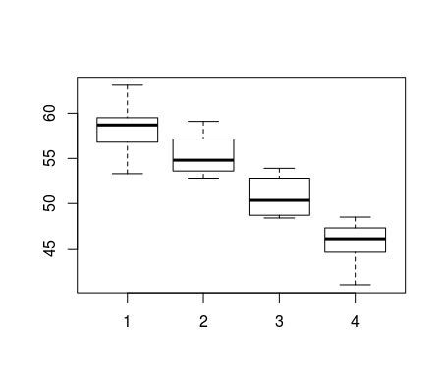Illustration 1: Box Plot of 4 pressures

H0: miu1 = miu2 = miu3 = miu4
H1: At least 2 miu are different
b) Yes, based on the box plot, I can say that there is the difference between at least two mean: the first type of pressure versus the fourth because they are of of their interval

c) The p value that was calculated is 6.34e-5. Since this is < 0.05, so we can reject the NULL hypothesis. That is , there is evidence that the mean Temperature of at least 2 pressures are different

d) Code is above

e) The data looks kinda straight but in my opinion, they are not. That is because there are still curves between each points in the same categories. In addition, from the picture, we can see that the slop are different

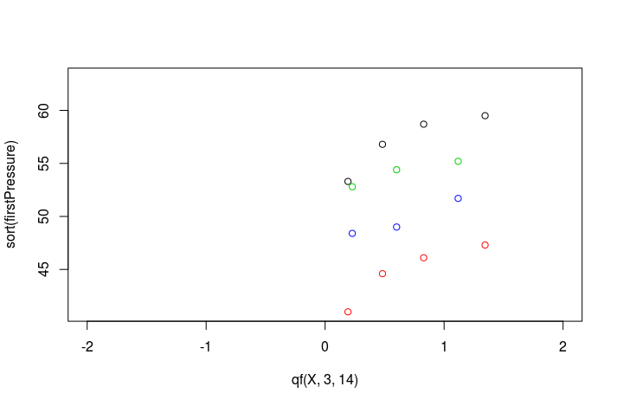Illustration 2: QQ Plot of 4 types of Pressure

